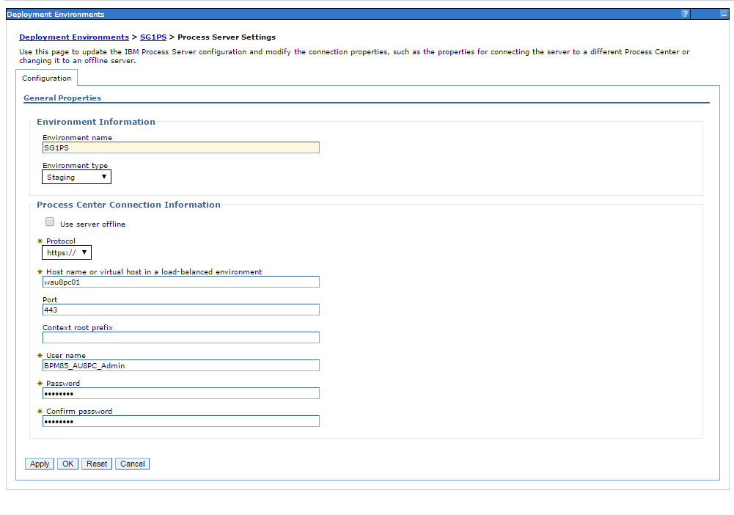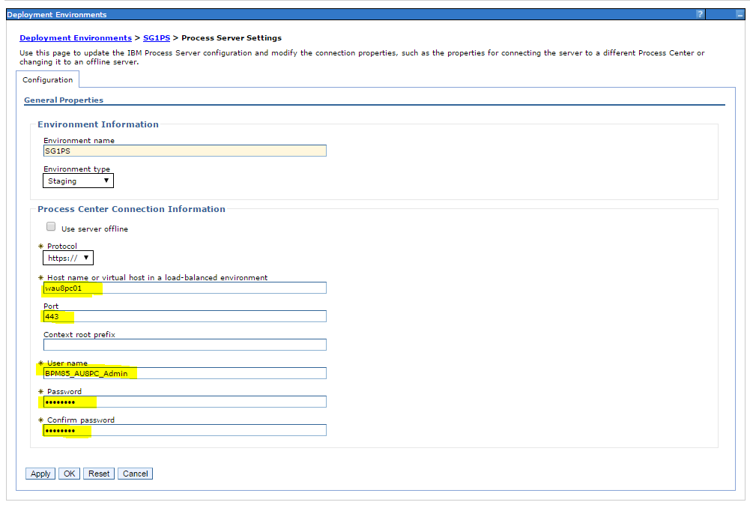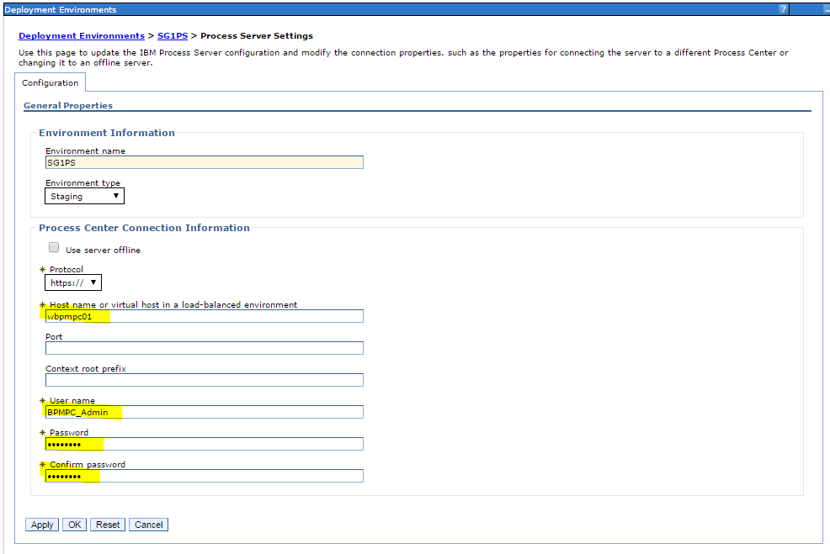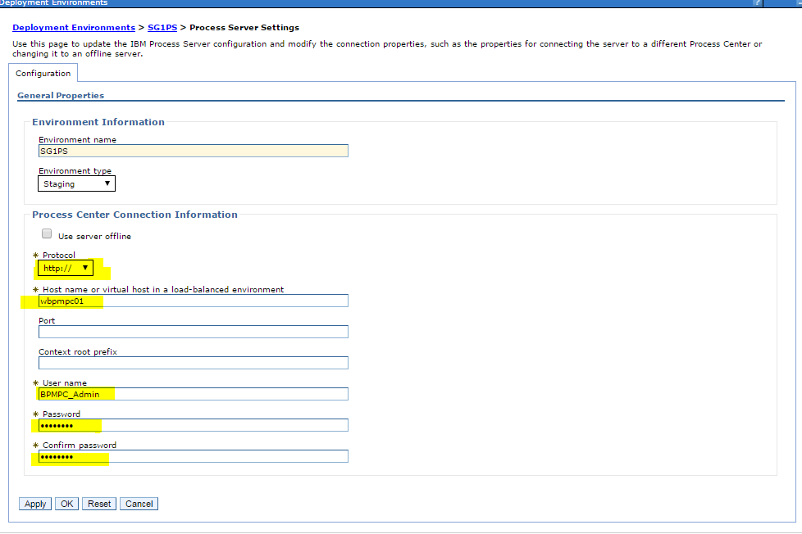

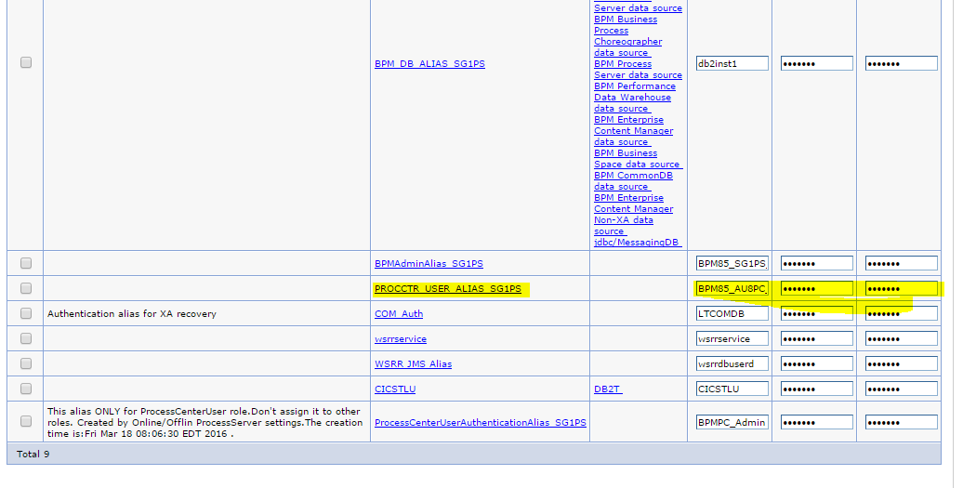

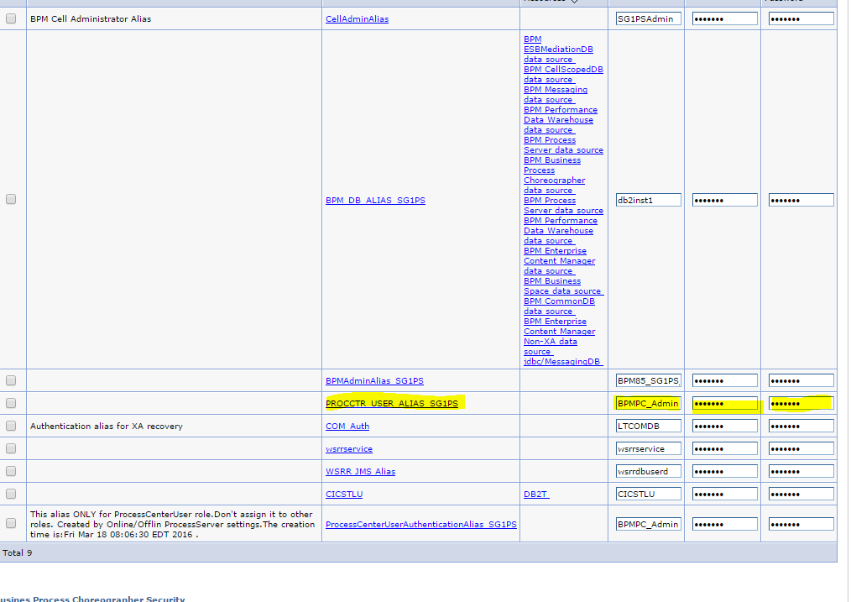

IBM link to configure the trust store:

https://www.ibm.com/developerworks/community/blogs/aimsupport/entry/ssl_connections_between_process_server_and_process_center_in_bpm_v8_0_1_x?lang=en